

**2025 Market Outlook – Good Luck Figuring This One Out**

In 2022, the S&P 500 fell nearly 20%. You may remember that 2022 was the year the Fed began raising interest rates to combat inflation. Those moves raised bond yields, encouraging investors to shift away from stocks in favor of debt securities. This rise-and-fall cycle is typical for the U.S. stock market and economy. The good times typically last longer, but weaker financial markets and economies can be more traumatic—emotionally and financially. The thing to remember is that no stock market climate is permanent. (Brock, 2024)

The stock market has been on a tear since its October 12, 2022 bottom, with the S&P 500 and Nasdaq 100 up 70% and 101%, respectively. A strong economy has dispelled any lingering fears of a potential recession, consumers are on solid footing, and perhaps most importantly, corporate earnings are rising to record levels. So, after back-to-back years of more than 20% returns for the S&P 500, what's in store for 2025? (Fox, 2024) Whether stock prices are heading up or down, there is always a reversal ahead. Keeping that in mind can help you manage whatever's in store for 2025 and beyond.

Pundits are largely optimistic about the U.S. financial markets in 2025, but with a good dose of caution. Five factors to watch in 2025 are the new Trump administration priorities, domestic inflation and interest rates, technology innovation, global economic trends and rising geopolitical tensions. But before getting into the details of these factors and their impact, let's start with the basics of what happened with the election(s) outcome and what that has meant—at least historically.

**New Trump Administration**

The table below puts the political power combination in the context of the stock market (Dow Jones Industrial Average), inflation (Consumer Price Index), economic growth (Coincident Economic Index) and debt-to-GDP levels. As shown, under the incoming configuration historically, market performance was decent and CPI decelerated; while economic growth was relatively muted and debt/GDP expanded slightly.

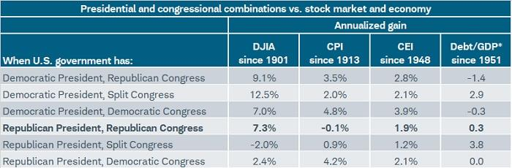 (Sonders & Gordon, 2024)

Justin Zacks, vice president of strategy at Moomoo Technologies, and Michael Martin, vice president of market strategy at TradingBlock, expect the priorities of the Trump administration to have a major influence on the stock market next year. Zacks believes the first 100 days of President Trump’s term will set the tone for the next four years (Brock, 2024). Trump campaigned on a platform of lower taxes and less-stringent regulations—seen as growth-positive—but also higher tariffs on imported goods and mass deportations of illegal immigrants—seen generally as stagflationary, at least initially. These crosscurrents and the uncertainties they are breeding make it difficult for stakeholders (both domestic and international) to plan for the future; potentially creating an environment of caution and concern across policy areas. Add to this a Federal Reserve operating in data-dependency mode, and we have a backdrop of reactionary market behavior and policy decisions (Sonders & Gordon, 2024).

Michael Martin points to the U.S. tariff policy and the national deficit as hot-button issues for the next president. New tariffs could slow the U.S. economy, Martin explains, which in turn could cause inflation worries to linger into 2026 and beyond. The deficit, unchecked, could contribute to the continued devaluation of the U.S. dollar. A breakdown of trust in the U.S. dollar could push investors to "alternative stores of value like gold and bitcoin," according to Martin (Brock, 2024).

**Tariffs**

Before getting into more detail on tariffs, let's get the basics out of the way. We often bristle at the short-hand typically used when describing tariffs; including headlines like "tariffs on China" or the United States wants to "charge Mexico and Canada" with additional tariffs. We know what those headlines mean, but many people do not (which has surprised us many times). The U.S. company importing the tariffed goods pays the bill; the countries targeted do not pay the bill. Who ultimately bears the cost depends on myriad factors, including price elasticity, pricing power and the pass-through to consumers, retaliations by targeted countries, exchange rate changes, etc. (Sonders & Gordon, 2024)

On the pro-growth side of the ledger are tax-related proposals (including the extension of 2017's tax cuts and the possibility of a further corporate tax cut). That's in addition to pro-growth deregulation policies being proposed. There may be a timing issue given policies around tariffs and immigration can largely be done via executive order, while tax changes require Congressional approval (Sonders & Gordon, 2024). Although it's "always different this time," there is a tariff-related playbook being dusted off from 2018's trade war. As shown below, once tariffs initially kicked in, initiating the trade war, the divergent paths for tariff-impacted categories vs. non-impacted categories became stark in terms of inflation. What had been a generally-disinflationary trend for several years inflected in terms of the tariff-impacted categories—kicking in just before the tariffs were detailed. Overall inflation remained fairly low in the 2018 era, in part because the narrower list of tariff-impacted goods were mostly in the intermediate and capital goods categories, not in most consumer categories (Sonders & Gordon, 2024).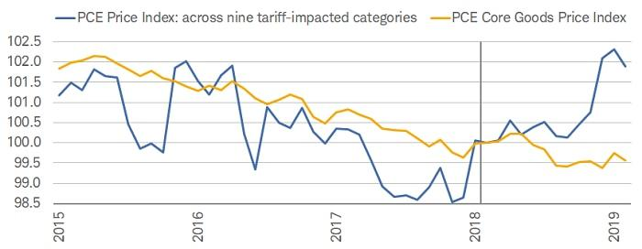 (Sonders & Gordon, 2024)

Using the 2018 playbook again, it's not a stretch to expect bouts of equity market volatility to kick in barring a retreat in uncertainty.

**Immigration**

In addition to tariffs, the other major policy to consider in 2025 is that of labor and immigration. Again, there is little we can glean at this point, given the lack of clarity when it comes to timing and the scope of both migrant inflow restrictions and deportations. However, what we do know—based on history—is that growth in real GDP and the labor force tend to move in tandem. As shown below, the rolling five-year changes in both are quite tight. In keeping with the aforementioned estimates from PIIE, we see the potential for slower growth if significant deportations take place (Sonders & Gordon, 2024).

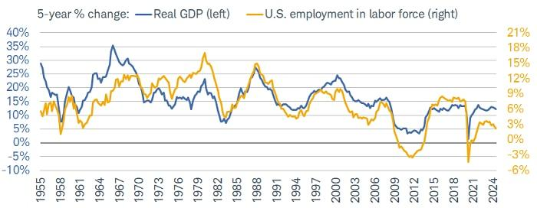

(Sonders & Gordon, 2024)

There has been a paper from the Peterson Institute for International Economics (PIIE) being widely circulated, covering a copious amount of research associated with the implications of Trump's proposed policies. The table below is a summary of some of those expected impacts. It includes two levels of deportations, the lower of which references deportation of 1.3 million people—while the other references what Trump believes are the 8.3 million unauthorized immigrants currently in the U.S. workforce. It also includes the proposed 10% increase in tariffs on all trading partners and the proposed 60% increase in tariffs on imports from China; while also including estimates under retaliation scenarios. In sum, it's a lower growth / higher inflation set of scenarios (Sonders & Gordon, 2024).

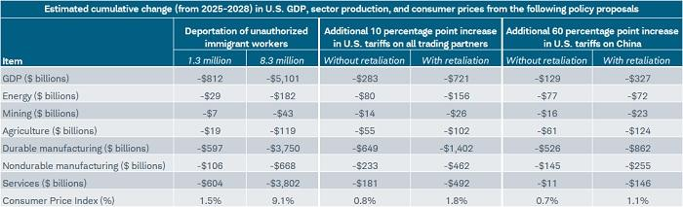

Source: Charles Schwab, Peterson Institute for International Economics (PIIE), as of 9/2024.

Forecasts contained herein are for illustrative purposes only, may be based upon proprietary research and are developed through analysis of historical public data.

**Inflation and Interest Rates**

The Federal Reserve on Wednesday lowered its key interest rate by a quarter percentage point, the third consecutive reduction and one that came with a cautionary tone about additional cuts in coming years.  In a move widely anticipated by markets, the Federal Open Market Committee cut its overnight borrowing rate to a target range of 4.25%-4.5%, back to the level where it was in December 2022 when rates were on the move higher. Though there was little intrigue over the decision itself, the main question had been over what the Fed would signal about its future intentions as inflation holds steadily above target and economic growth is fairly solid, conditions that don’t normally coincide with policy easing. The Fed indicated that it probably would only lower twice more in 2025, according to the closely watched “dot plot” matrix of individual members’ future rate expectations. The two cuts indicated a slice in half the committee’s intentions when the plot was last updated in September (Cox, 2024).

The cut came even though the committee jacked up its projection for full-year 2024 gross domestic product growth to 2.5%, half a percentage point higher than September. However, in the ensuing years the officials expect GDP to slow down to its long-term projection of 1.8%. Other changes to the Summary of Economic Projections saw the committee lower its expected unemployment rate this year to 4.2%, while headline and core inflation according to the Fed’s preferred gauge were pushed higher to respective estimates of 2.4% and 2.8%, slightly higher than the September estimate and above the Fed’s 2% goal (Cox, 2024).

Micheal Martin questions whether the Fed's 2% inflation target is realistic. If it's not and rates remain higher as a new normal, profit margins could suffer. Broadly lower profitability will stifle stock market growth. Justin Zacks believes there is a possibility we'll see stagflation next year, for example. Stagflation is persistent inflation despite a softening economy and labor market. He cites changing tariff policies and geopolitical tensions as potential catalysts (Brock, 2024).

**Technology Innovations**

Technological innovation has recently been a primary growth driver for the stock market, creating some of the best stocks of 2024. As an example, semiconductor company Nvidia (NVDA) has increased its stock price by 178% by decisively monetizing demand for high-performance computing resources. Nvidia's graphics processing units are a preferred resource for machine learning workloads.

For better or worse, the stock market will respond to further developments in artificial intelligence in 2025. One uncertainty is whether AI can deliver on its promises of efficiency and productivity. Billions are being spent on AI development and the return expectations are high. Many experts believe AI will prove itself, fueling higher earnings expectations and, in turn, higher stock prices (Brock, 2024).

**Global Economy**

Angelina Hu, global head of investor relations at SALT Venture Group, cites ongoing economic slowness in China as a potential limitation for stock market growth in 2025. A sluggish Chinese economy weakens demand for U.S. exports. China's finance ministry has announced plans for a stimulus package, but the details of that program are still unknown. Companies with significant exposure to China may experience volatility as the stimulus plans take shape (Brock, 2024).

Goldman Sachs Research forecasts another solid year of global economic growth in 2025. Goldman’s economists project the US will outperform expectations while the euro area lags behind amid fresh tariffs that are anticipated from the Trump administration. Worldwide GDP is forecast to expand 2.7% next year on an annual average basis, just above the consensus forecast of economists surveyed by Bloomberg and matching the estimated growth in 2024. US GDP is projected to increase 2.5% in 2025, well ahead of the consensus at 1.9%. The euro area economy is expected to expand 0.8%, compared to the consensus of 1.2% (Goldman Sachs, 2024).

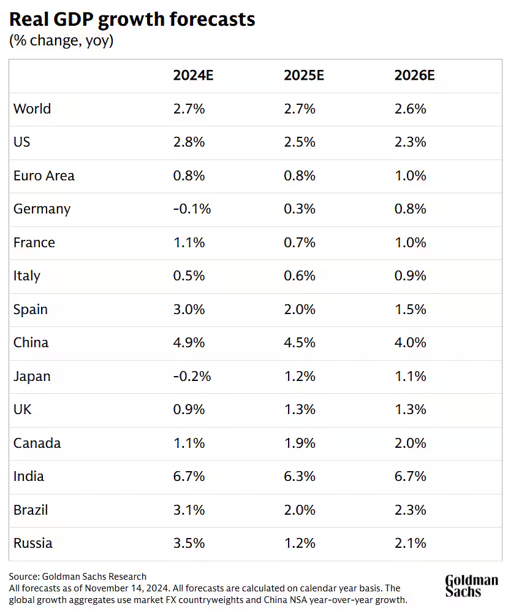

**Geopolitical Tensions**

2024 saw no shortage of tectonic geopolitical developments: the entry of long-neutral Sweden into NATO, Ukrainian forces’ incursion into Russia’s Kursk region, Israeli strikes in Iran and Lebanon, the election of Donald Trump, the fall of Bashar al-Assad’s regime in Syria, and the impeachment of South Korean President Yoon Suk Yeol soon after he declared martial law (Froman, 2024).

Thus far, the war in Ukraine and rising conflict in the Middle East have not created major problems in the U.S. financial markets. This could change if unrest escalates to the point of disrupting global trade or commodities supply. Another concern is the engagement of U.S. troops on foreign soil, which would likely sour investor sentiment and take a toll on stock prices in the process (Brock, 2024).

The Middle East seems poised to dominate headlines. Will post-Assad Syria unify disparate opposition groups? Or will it remain a failed state, only this time, run by Islamists? Syria’s fate will not only define the future for the country’s twenty-three million people but also have a significant impact on its immediate neighbors: Turkey, Iraq, Jordan, Lebanon, and Israel. And then there is the Israel factor: Israeli leaders are filled with confidence after defying outside entreaties to end the war in Gaza and de-escalate their country’s conflicts with Iran and Hezbollah. Euphoric and emboldened, they may decide that this is the year to strike Iran’s nuclear program and set it back years (Froman, 2024).

Trump has promised to end the conflict there, but the fact remains that the Ukrainian and Russian visions of a settlement differ wildly, and Russian President Vladimir Putin has shown little interest in serious negotiations. Rather than end, the conflict may well escalate in 2025. This week, a Ukrainian operative assassinated a high-ranking Russian general in Moscow, and earlier, Putin threatened to target “decision-making centers” in Kyiv with a new ballistic missile. But over the course of next year, Putin will likely face mounting domestic problems. Russia’s central bank has forecast economic growth of 0.5 to 1.5 percent in 2025, down from 3.5 to 4 percent in 2024, suggesting that the wartime boom may have run its course (Froman, 2024).

China remains preoccupied with Taiwan. Last week, China held its largest maritime military exercises in decades. Involving nearly ninety vessels, the drills seemed designed to send the message that Beijing had the power to blockade the island and prevent U.S. allies from coming to its rescue (Froman, 2024).

The biggest humanitarian crisis in the world at the moment is the civil war in Sudan, which has been raging since the spring of 2023. The crisis is only expected to get worse in 2025, as outside powers—including the United Arab Emirates and Saudi Arabia—continue to meddle in the conflict (Froman, 2024).

Latin American nations, already struggling to absorb twenty million forcibly displaced migrants, are bracing for a renewed exodus from Venezuela as Nicolas Maduro holds onto the presidency in defiance of the 2024 election results (Froman, 2024).

Against this geopolitical backdrop are some worrisome economic trends: potential tension between Trump and the Federal Reserve, the impact of tariffs—and retaliation—on China as well as on U.S. allies and partners, the unsustainable trajectory of U.S. deficits and debt. And all these trends are mounting at a time when the markets are “priced for perfection,” meaning they assume the best about the year ahead (Froman, 2024).

# References

Brock, C. (2024, October 29). *What's coming next year?* Retrieved from Forbes.com: https://www.forbes.com/sites/investor-hub/article/stock-market-predictions-2025/

Cox, J. (2024, December 18). *Fed cuts by a quarter point, indicates fewer reductions ahead.* Retrieved from CNBC.com: https://www.cnbc.com/2024/12/18/fed-rate-decision-december-2024-.html

Fox, M. (2024, December 13). *Here's a complete rundown of Wall Street's 2025 stock market predictions.* Retrieved from businessinsider.com: https://markets.businessinsider.com/news/stocks/2025-stock-market-investment-outlooks-wall-street-prediction-roundup-sp500-2024-12?op=1

Froman, M. (2024, December 20). *What we're watching around the globe in 2025.* Retrieved from CFR.org: https://www.cfr.org/article/what-were-watching-around-globe-2025

Goldman Sachs. (2024, November 15). *The global economy is forecast to grow solidly in 2025 despite trade uncertainty.* Retrieved from goldmansachs.com: https://www.goldmansachs.com/insights/articles/the-global-economy-is-forecast-to-grow-solidly-in-2025

Sonders, L., & Gordon, K. (2024, December 9). *2025 US stocks and economy outlook.* Retrieved from schwab.com: https://www.schwab.com/learn/story/us-stock-market-outlook

*Roan Capital Partners is a registered investment adviser. Information presented is for educational purposes only and does not intend to make an offer or solicitation for the sale or purchase of any specific securities, investments, or investment strategies. Investments involve risk and, unless otherwise stated, are not guaranteed. Be sure to first consult with a qualified financial adviser and/or tax professional before implementing any strategy discussed herein. Past performance is not indicative of future performance.*